In Africa, We Work With the Best
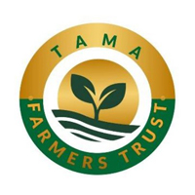
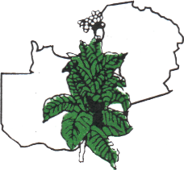
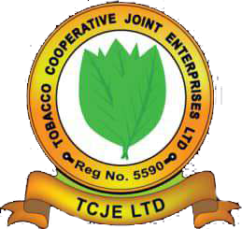


ITGA: 40+ Years of Experience in Africa
🤝 Working alongside growers and tobacco sector stakeholders in Malawi, Tanzania, Zambia, and Zimbabwe
🧑‍🌾 From regional meetings to international advocacy, ITGA brings the sector together

Where the Sector’s Conversation Happens

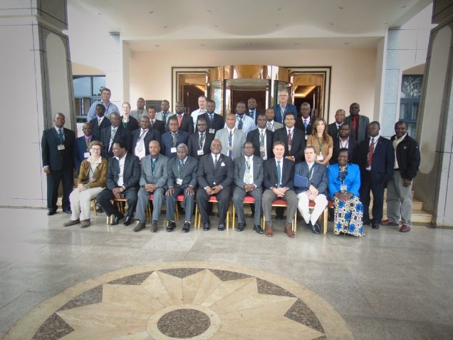
Malawi 2025
Malawi 2015

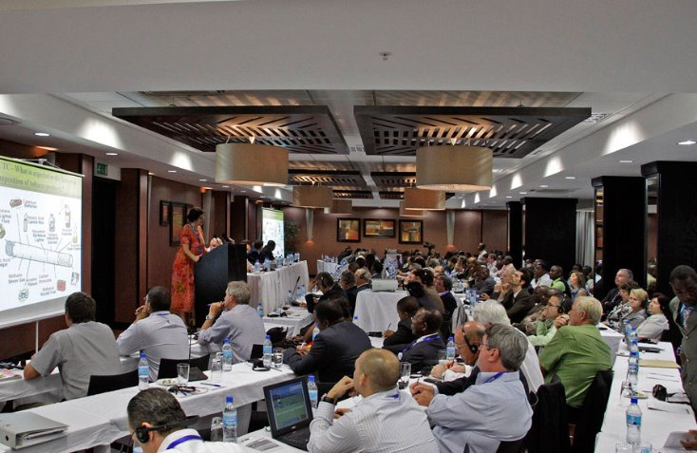

Tanzania 2023
Tanzania 2011

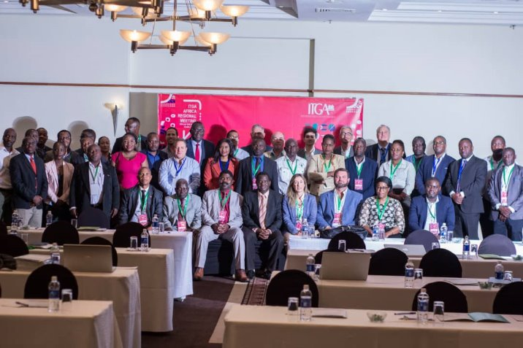
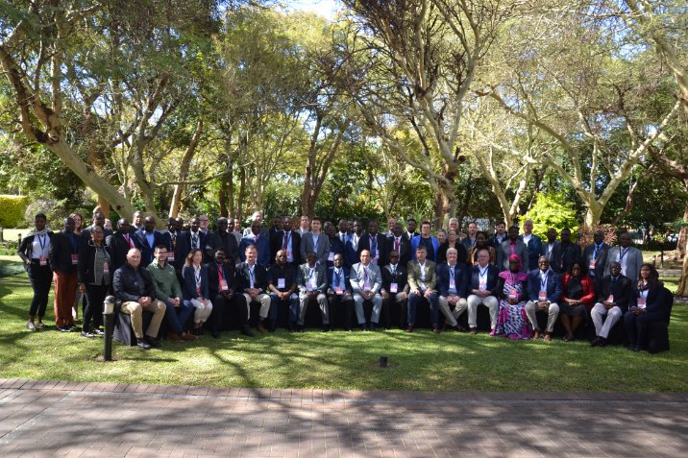
Zambia 2022
Zambia 2024

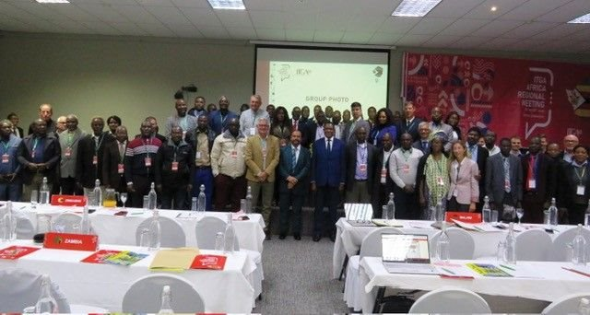
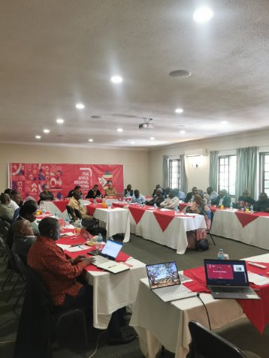

Zimbabwe 2023

Sustainabiity Projects and On the Ground Connection with Farmers
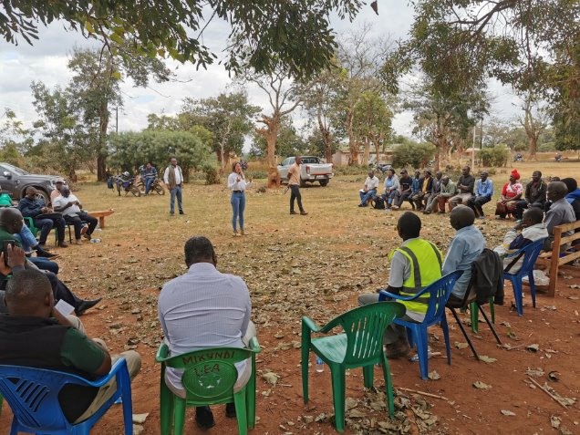
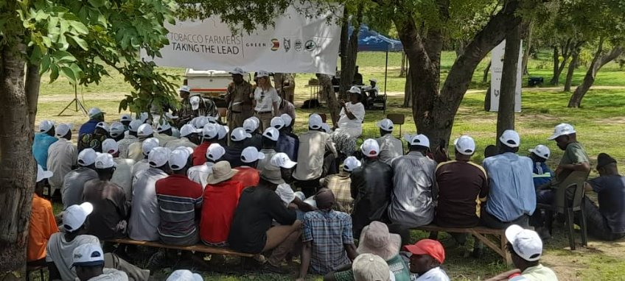
Zimbabwe 2022
Malawi 2025

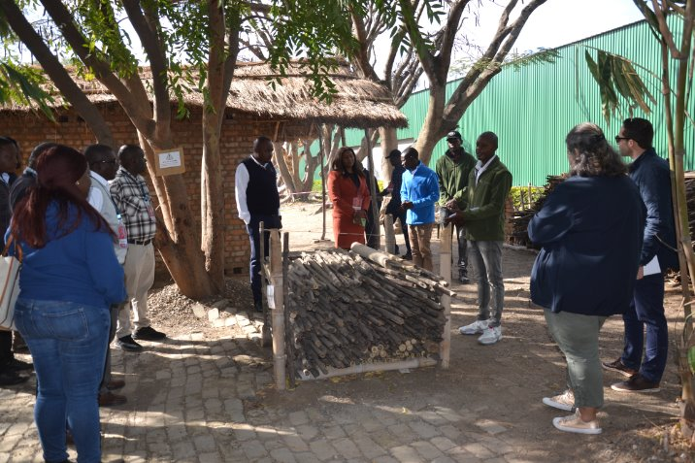
Training Season Capacity Building
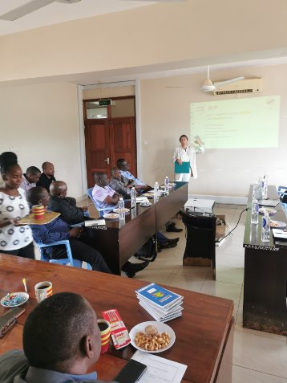
Zambia 2024
Tanzania 2023

